THE NOCK
Welcome to the January edition of The Nock.  Accidents & Incidents  If you have an accident or incident on the field or at the High School it is essential that you let Sarah Czyrko know, via email within 24hrs at secretary@droitwicharchery.co.uk  New to the club?  If you are new to DAS and want to ask a question, please contact any of our coaches, the secretary of the club or your Members’ Representative.  Newsletter  Want to tell the members’ something in the newsletter? Have archery items to sell? Please forward your article to Sarah Czyrko secretary@droitwicharchery.co.uk  Raffle Prizes  If you are having a clean out at home and have some suitable raffle prizes for upcoming tournaments please email/provide to Sarah who will be more than happy to store them.  Who’s Who in your club  Chair:  Peter Sargent  Finance:  Karon Adamson  Coaches:  Becky Lashley (Lead Coach)  Dave Vukomanovic  Patti Vukomanovic  Neil King  Martin Finch  Sarah Czyrko  Rob Monk  Sue Monk  Secretary:  Sarah Czyrko secretary@droitwicharchery.co.uk  Members’ Representative:  Chris Morris  Equipment Officer:  Peter Sargent  Tournaments Organiser:  Peter Hughes  tournaments@droitwicharchery.co.uk  Records Officer:  Natalie Doody records@droitwicharchery.co.uk  Members’ Representative  Chris Morris is the DAS club Members’ Rep. Chris will often ask for you views both positive and negative about the club. He would also like to hear about any ideas you might have to improve the club and facilities. Please let him know and he will present your ideas at our regular committee meetings.  Coaching & Development  Coaches will be available on the following dates:  - Saturday 1st February  - Tuesday 11th February  - Saturday 15th February  - Saturday 29th February  - Saturday 7th March  - Tuesday 10th March  - Saturday 21st March  - Tuesday 31st March  Shooting Times  From Saturday 4th Oct:  Saturday 10am Indoors (Droitwich High School)  Tuesday 7pm Indoors (Droitwich High School)  Easy Fundraising  Boost club funds while doing your shopping!  Full details are available  https://www.easyfundraising.org.uk/causes/droitwicharchery  The Rotary Club: Droitwich Spa  DAS have received a very generous donation of £800 from The Rotary Club in recognition of our contribution to the Santa sleigh. Thanks to all who helped with the walkabouts.  County News  Upcoming courses:  29.02.20 Recurve bow set up  Further details can be obtained from County of Worcester Facebook page. | To Karon Adamson (nee Higgs) who married George on Saturday 11th January. We wish Karon and George a wonderful and restful honeymoon.  Classifications  Ben Wood Recurve E Class  Tara Cogley Recurve D Class  Natalie Doody Recurve D Class  Portsmouths  Tara Cogley Junior Ladies Recurve 450 & 475  Emelia Hughes Junior Ladies Recurve 525  Ben Hodgetts Junior Gents Recurve 475  Ben Wood Junior Gents Recurve 400 & 425  Mark Wragg Gents Recurve 500 & 525  Chris Morris Gents Longbow 350  Richard Sagar Gents Compound 550  Rob Monk Gents Recurve 500 & 550  Club Records  Marc Hache Gents Barebow Vegas score of 292  Gents Barebow WA 25m score of 447  Gents Barebow Portsmouth (Triple) 488  Emelia Hughes Junior U14 Recurve Bray I score of 255  Kevin McInerney Gents Recurve WA 18m score of 563  Gents Recurve WA 25m score of 553  Coaches  The committee would like to invite any DAS member who would like information to train to be a Level 1 or Level 2 coach to apply to the secretary via email for further details on how to apply.  For Sale  £40:  please contact Carrie McHattie or  Sarah Czyrko  Beginner’s Courses  We are aware that some members would like to know about upcoming Beginner’s Course and Taster Sessions so that friends and family can sign up.  We shall now include details of dates in our newsletter; booking is via our DAS website.  - Taster session Sat 29th Feb.  - Beginner’s Course:  - Sat 21st March 1.30-4.30 @ Droitwich HS  - Sat 28th March 1.30-4.30, possibly at 6GE – tbc  - Sat 4th April @ 6GE  - Sun 5th April @ 6GE  Committee Meetings  Committee meetings are held every other month. If you would like to see a copy of the minutes, please contact secretary@droitwich.co.uk  New Club Shirts  Following the article in the November edition of The Nock, Club Committee have now completed the promised review of the club shirt design.  The current shirt colours reflect those selected by the Club when AGB introduced club colours about 12 years ago. DAS got together with other Worcestershire clubs to ‘share out’ colours to avoid a clash and the combinations were put to a vote - royal blue and white won. It was championed then by well-known former member Nick Gilbert, who passed away shortly afterwards.  Since then the notorious AGB Rule 307 on Dress Regulations has been considerably relaxed and archers may now wear pretty much what they like – outside of World and Olympic events.  Kevin McInerney ably investigated members’ preferences and concerns which briefly included the following, many dominated by issues about the specific material and the dominance of white including:  - terrible for stains from spills of food and drink when at competitions  - bad for leaving pen mark's when scoring at competitions  - not good for hiding a multiple of body lumps and bumps  - harder to keep clean and doesn't allow for a hot wash when you have blue and white together  - becomes see through when wet and cold  - fairly transparent to coloured undergarments  Club Chair contacted Lionhart who specialise in archery apparel and have an impressive list of happy clubs. The brief was set to include:  - respect for the club blue and white  - recognise the Droitwich connection, heritage and if possible, colours (red, black, white)  - patterns should recognise shirts have to fit all shapes and sizes  - note that whilst white is a good colour in summer when its hot, it does also tend to show/reveal undergarments (It also looks particularly grubby if not washed)  - designs should be dynamic and reflect the sport without being gimmicky  - there could be 2 colourways, a dark and a light, to give some individuality or for indoor/outdoor seasons  In total 10 designs were submitted and assessed, with 3 making it to a shortlist for members to choose. Whilst these are included at the end of the newsletter, the intention is to display them with a voting sheet at club meeting over January. Assuming there is a preferred choice these will then be available to order shortly after.  Please do get involved and vote, and if there are comments make them known to Club Chair or Membership Officer, Chris Morris.  From Equipment Officer  Whilst the Winter period offers a break from the maintenance of the field, this Winter has made life particularly easy!  The weather has been horrendously wet since October and led to the request to members not to use the field for shooting. Even the limited access required to remove and return equipment for the competitions at RGS have led to surface damage.  As recently as the beginning of January it seemed we were but days away from allowing members to shoot again, but no – the wet weather returned with a vengeance and the field is now as soggy as at any time previously.  The Committee will be considering what recompense, if any, we can make to those Anytime members who have been severely disadvantaged, even noting by a higher authority than Club Management!  The indoor target faces have taken a severe battering since September and new faces have been provided. Please try to make these last – particularly by giving the gold centres a good ‘seeing to’ as they can be mended with patches!  Should you find that you need a particular target face and its either missing or in too poor a condition, please let me know and I will rectify as soon as I can.  Otherwise, just a few words of caution.  - As archers get better, their poundage increases and their arrows pass through the straw and will damage the frames, causing splinters large and small. Please take care when handling the frames and ask me for any areas to be wrapped with the tape kept in the store for this purpose.  - Finally, a member was hit by a falling safety curtain support recently. If assisting in setting up or taking down the curtain note and check the following –  - That each prop is held by a capable person or leant against the wall  - That you and those involved have the necessary strength and ability to do the job assigned – especially the person handling the end of the rope  - Make sure the step ladder is properly set up and preferably held by another person whilst using  Peter Sargent – Equipment Officer  Droitwich Archery Society’s WA 18/25m Combined on Sunday 19th January 2020.  Thank you for attending Droitwich Archery Society’s WA 18/25m Combined on Sunday 19th January 2020.  We hope you enjoyed the day and look forward to welcoming you to one of our future events.  Saturday 14/03/2020 CWAA (& Open) Junior Indoor Championships.  UK Record Status Junior Tournament - Portsmouth Round at Droitwich Spa High School (incorporating the John Williams novice awards).  Sunday 12/04/2020 Easter Sunday Spring Tournament. A great early season opener! Come and shoot any variation of the WARWICK round. Shoot two rounds with different bow types if you prefer! You decide what to shoot. Grab yourself an elusive UK Record.  We’ll also be holding our first WA Double 720 event on Sunday 12th July.  Further details and entry forms can be found at: http://www.worcestershirearchery.co.uk/html/tournaments.php
Upcoming Tournaments:
Date | Club | Round | Details
25/01/20 | Redhill | Novice Portsmouth | Wythall Park, B47 6LZ  An event for Novice archers with little or no competition experience. Two sessions sighters at 9.30am and 1 pm To enter you must have completed your Beginners course within the last 12 months
09/02/20 | Wyre Forest C of Archers | WFCA 31st Annual UKRS Portsmouth | Held at: Wyre Forest Leisure Centre, Stourport Road, Kidderminster, DY11 7DT  Sighters: Session A 9.30am Session B 12.30 approx  Snrs £10 / Jnrs £8
01/03/20 | Redhill | Open Double Vegas 300 Tournament | 4th Open Double Vegas 300 Tournament. Two rounds of 30 arrows. Practice 10:00 AM and 13:30. Please read the rules we will be adhering to carefully, they can be found on the entry form.
14/03/20 | Droitwich Archery Society | CWAA (& Open) Junior Indoor Champs | UK Record Status Junior Tournamant - Portsmouth Round at Droitwich Spa High School. (Incorporating the John Williams novice awards)
12/04/20 | Droitwich Archery Society | Easter Sunday Spring Tournament | A great early season opener! Come and shoot any variation of the WARWICK round. Shoot two rounds with different bow types if you prefer! You decide what to shoot. Grab yourself an elusive UK Record.
19/04/20 | Wyre Forest C of Archers | County of Worcester County Trials | County of Worcester County Trials, WA1440 and Metrics 1-5 - Invitation Only.
07/06/20 | Wyre Forest C of Archers | WFCA Annual Western | Western, Short Western, Junior Western, Short Junior Western at Upper Arley, Nr. Bewdley, Worcestershire, DY12 1XG
12/07/20 | Droitwich Archery Society
02/08/20 | Wyre Forest C of Archers | WRS County of Worcester and Open WA1440 and Metrics | WRS WA1440 and Metrics 1-5 at Upper Arley, Nr. Bewdley, Worcestershire, DY12 1XG
01/11/20 | Wyre Forest C of Archers | UKRS 4th Annual WA18m | UKRS WA18m

Club Shirts
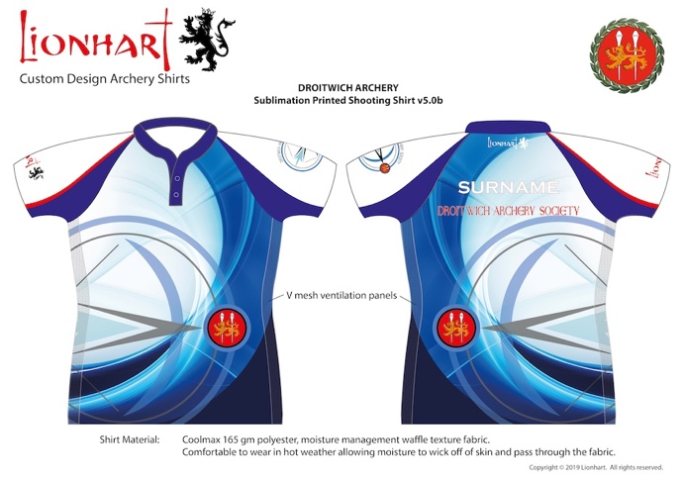Option A
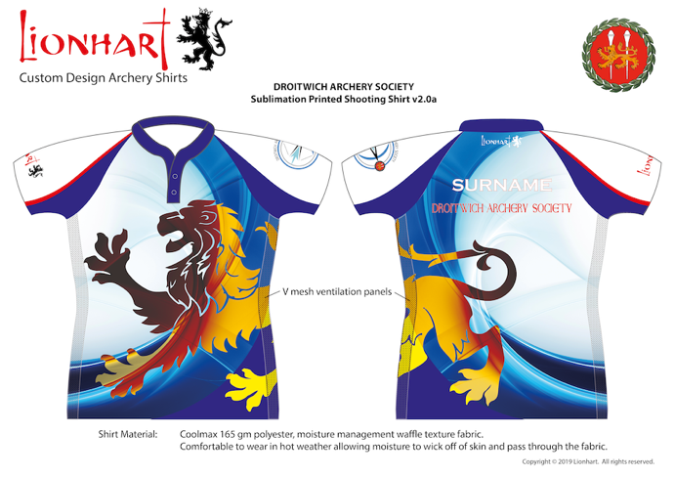Option B
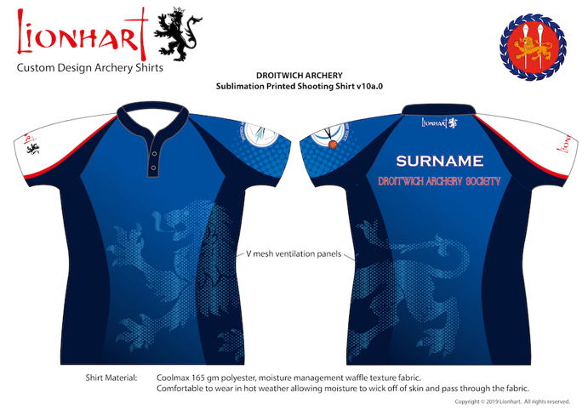Option C
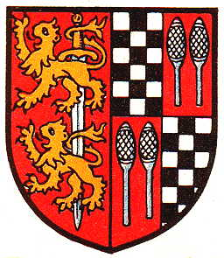
Droitwich Heraldry and Sports & Social Club official symbol as used on current shirts.

